**Data for Local Calibration of Indices Project**

**Example site: Dark Peak**

Dark Peak SSSI (for peatland)

* The entire site is covered by granule 30UWE. Total area 318 km2. Good to test a larger area as most peatland sites are large.
* The Dark Peak has blanket bog in a range of condition states, as in the past it was heavily degraded but has undergone intensive restoration in the last 20 years. There are likely to be only a few areas with very good condition 5 and 6 bog status. Other habitats are acid flushes, Molinia dominated, dwarf shrub habitats, so a great interest here is wetness from NDMI and NDWI
* <https://designatedsites.naturalengland.org.uk/SiteDetail.aspx?SiteCode=S1003028>
* Opportunity for end user engagement: Moors for the Future
* Peat restoration, grip blocking and Sphagnum propagation are likely to lead to change.



Method used to generate “zonal statistics”

1. Formatted spatial framework (shapefile of Dark Peak habitat polygons, a section from the Living England map) to remove small polygons (<100m2) and unwanted habitat types
2. Processed Sentinel ARD to give indices layers (NDVI, NDMI, NDWI, RVI, RVIv)
3. Extracted indices values for each habitat polygon in the spatial framework and generated summary statistics for each Sentinel layer date (statistics= mean, standard deviation, median, min, max, Q1 and Q3)

Data included:

1. 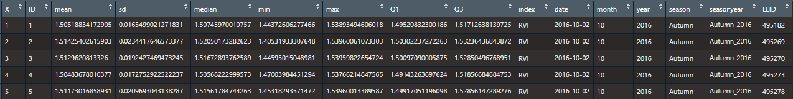.json files for each Sentinel layer date (e.g. “s1_zonal_stats_2016-10-02.json”)

X = row number

ID = assigned polygon number

Mean, sd, median, min, max, Q1, Q1 = stats values for index layer

Index = index data relate to

Date = date of Sentinel data layer

Month, year, season, seasonyear = date broken down for the app

LEID = corresponding polygon ID in Living England layer

1. Summary .json file for all dates “DarkPeak_full_zonal_stats.json”
2. Formatted spatial framework (Living England) shapefile “DarkPeak_LE_Segments_Spatialjoin_10m_formatted.shp”
3. Bounding box shapefile “dark_peak_bounding_box.shp”
4. Living England ID lookup table (as .txt file) “darkpeak_LEID.txt”
   1. This gives the Living England polygon IDs for the assigned polygon IDs
   2. Probably won’t need this as I added a Living England ID column to the zonal statistics files

Any questions about the data, please let me know!